Bart Ellenbroek obtained his PhD in 1988 from the Radboud University of Nijmegen the Netherlands, and after a few years working in several different countries, joined Victoria University of Wellington in 2012. Trained as a behavioural neuroscientist and pharmacologists, his research initially focussed on developing animal models for psychiatric disorders such as schizophrenia, drug addiction and autism spectrum disorders.
However in recent years, he has become very interested in how the brain (and behaviour) changes over time. This has led him to investigate neurodevelopment in animals and humans and how certain drugs such as alcohol and psychedelics change our brain an and behaviour.
His work includes animal research (rats and planaria) as well as research in humans. Acknowledging the enormous complexity of the brain, he is a strong proponent of collaboration and established many past and ongoing collaborations.
For more information on his work an---d publications, please see Google Scholar

In his private life he is married to Jiun Youn, has two daughters, one son, two dogs and two budgies.

MENGQI ZHANG

Hi I am Mengqi I joined NEST in the middle of 2025. I am a PhD researcher working on the effects of psychedelic compounds on neurogenesis, using planarians as a model system. My research focuses on molecular and cellular mechanisms related to drug development, rather than behavioral studies. I have strong laboratory experience and work mainly with molecular biology, immunohistochemical and pharmacological techniques. I am interested in how basic neuroscience research can support drug discovery.

SASHA MIDDLETON
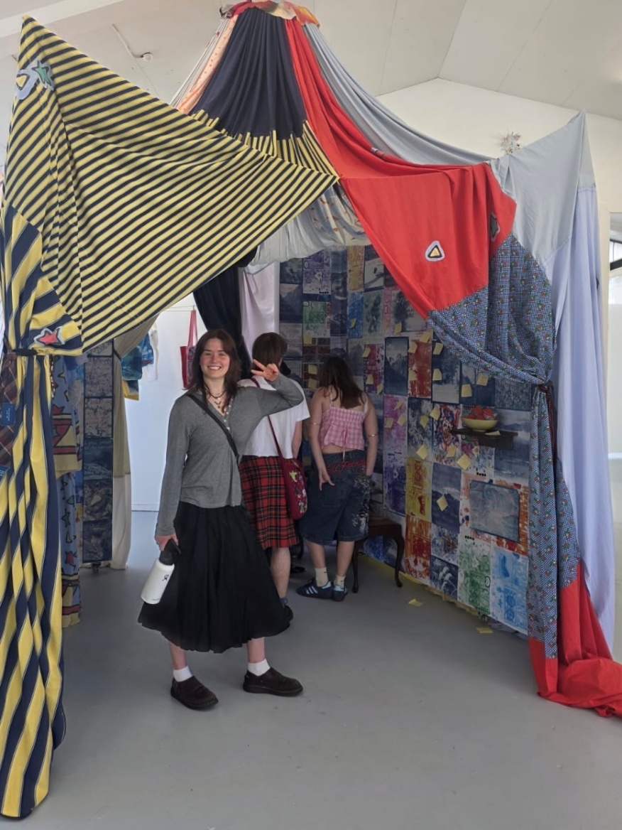

Hi! I’m Sasha a fourth-year psychology student finishing off my BPsyc, majoring in Brain Science and Mental Health! As part of my SCIE306 course, I am very excited to work on a research project investigating the addictive properties of methamphetamine in planaria. As part of the project, I will be optimizing a computer program designed to automatically analyse activity, shapes and behavior of planaria.
A huge range of psychological research interests me, but learning about neurobiology and gene-environment interactions, especially the imapct of the gut microbiome, especially piques my passion. This year, I am also doing an internship under the Tindall Foundation utilising exisiting kaupapa Māori and/or Pasifika frameworks and methodologies to support the mental well-being of birthing parents in their perinatal phase.

Hi, I'm Alex, a PhD candidate and Research Assistant in the NEST. I pitch in to help students wherever asked (usually in the biology lab or writing feedback), while my own work focuses on how maternal inflammation during early/mid-pregnancy may impact the foetoplacental regulation of serotonin. Serotonin has its sticky fingers in the activity of everything from microglia to mitochondria, so changes in prenatal serotonin availability may have a plethora of downstream neurodevelopmental implications. This includes in the symptomology and aetiology of diagnoses such as schizophrenia spectrum, autism spectrum, and depressive disorders. There's plenty of PhD's worth of research left to do in this area - if you're looking for something interesting to research, I can recommend it and am happy to chat about it!

